**Learn more about Google Search Console**

Google Search Console is a free tool that allows people to learn useful information about their business’ website. The tool lets users monitor, maintain, and troubleshoot their site’s presence, which increases the site’s overall performance and makes users more likely to enjoy spending time on the site.

Google Search Console has lots of capabilities. Whether you want to see an analytics report of your site, make HTML improvements, set up sitemaps, or something else, Search Console gives you total control over your website.

If you are interested in learning more about Google Search Console, check out the video series below.

* [Google Search Central: Google Search Console Training](https://www.youtube.com/playlist?list=PLKoqnv2vTMUOnQn-lNDfT38X9gA_CHxTo)

**TOOLS**

More tools and reports in Google Search Console

As you learned in a video, **Google Search Console** is a tool that helps you better understand how your website is performing. It helps you manage your website’s presence in search engines and make it easier for more people to find your site. This reading will introduce a few of the tools and reports available in Google Search Console.

**Sitemaps report**

The sitemaps report in Google Search Console allows you to submit or update your **sitemap**, which is a file that provides information about the pages, videos, and other files on a site, and the relationships between them.

A sitemap helps Google find the most important pages on your website that you would like to appear in search results. It also helps Google understand the relationship between the pages on your site.

You might not need to submit a sitemap if your site is small and already being crawled by Google. However, submitting a sitemap can help Google improve how it crawls your website—especially if your website is larger and includes more than 500 pages.

Some website platforms, such as WordPress, Wix, and Blogger, automatically create a sitemap for you and make it available to search engines. In that case, you don’t need to submit a sitemap. If your website platform doesn’t automatically create and submit a sitemap, you can use the sitemaps report in Google Search Console to do so.

The sitemaps report allows you to find out which sitemaps have been submitted for your website, access sitemap statistics, and monitor any errors that Google may have encountered when processing your sitemaps.

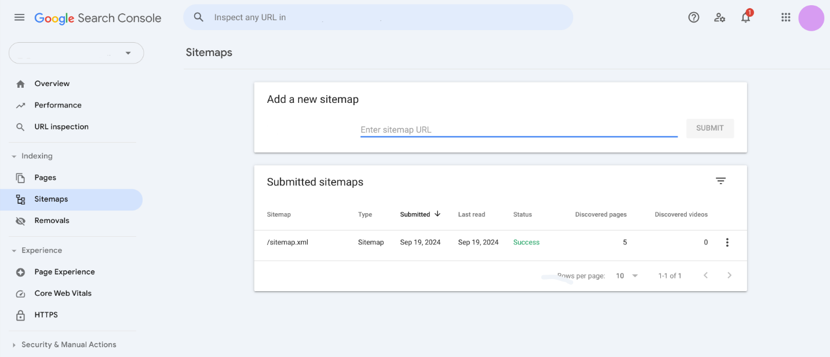

**URL inspection tool**

Another tool that Google Search Console offers is the **URL inspection tool**, which provides detailed crawl, index, and serving information about your pages, directly from the Google index. It allows you to access the information that the Google index has about a specific URL on your website. It also allows you to test a live page on your website.

The URL inspection tool reveals errors on the page, such as HTML or JavaScript code errors. It also reveals other technical information. This tool is helpful for troubleshooting any crawling errors that Google encountered on your site. It’s also helpful for fixing and retesting a page with errors.

**Change of address**

If you move your website from one domain to another, you’ll need to let Google know by using the change of address tool. For example, if your website address was example.com and you later changed it to example.org, you would use this tool to let Google know about the change. Then Google can migrate your Google Search results from your old website to your new one.

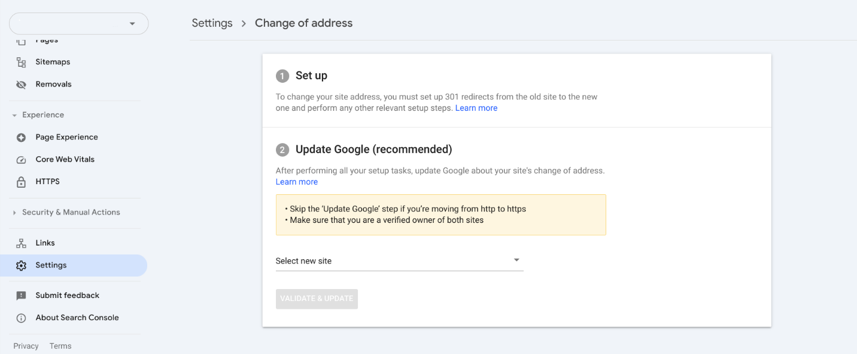

**Removals tool**

In some cases, you may want to prevent a webpage on your site from appearing in Google Search. A temporary fix is to use the **removals tool**, which allows you to temporarily block pages from Google Search results and manage SafeSearch filtering.

The temporary block will only last about 6 months, however. To permanently remove the page from Google Search results, you will need to do one of the following:

* Remove or update the page
* Block access to the content by requiring a password or using another method to restrict access
* Add code to the page that tells search engines not to index it (this method is less secure than the other two methods)

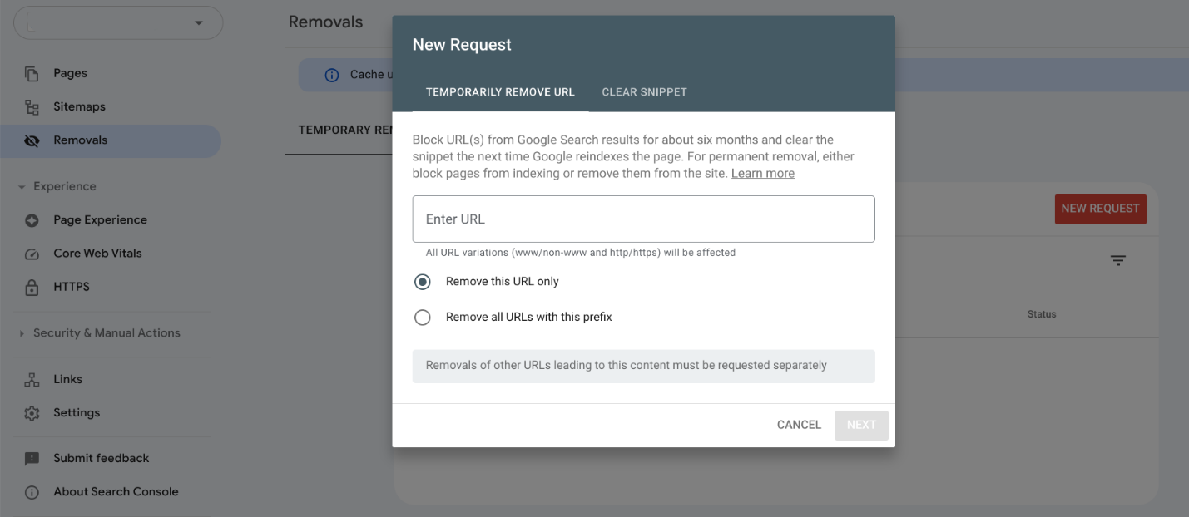

**Key takeaways**

Google Search Console provides tools to help you monitor and manage your website’s performance. Using these tools can help more people find your website.

**Resources for more information**

Get an overview of the tools and reports available in Google Search Console.

* [Google Search Console](https://support.google.com/webmasters/answer/9133276): Read about the tools and reports available in Google Search Console.